Now Hiring Lifeguards!
Let’s make summer happen!
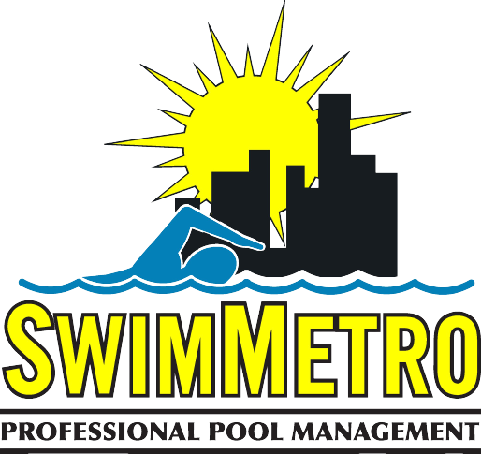

SwimMetro is excited to be partnering with Woodland Pond this upcoming summer!

SwimMetro employees enjoy:

- Team oriented work environment
- Flexible Hours
- Quick Commutes
- Opportunities for Advancement and Development
- Local Administrative and Supervisory Support
- Valuable Work and Resume Experience

Check out swimmetro.com to apply or sign up for lifeguard classes!

Follow us on Instagram- @SwimMetro, and Facebook - SwimMetro Lifeguards.

If you have any questions or issues regarding the hiring process, please contact Rachel at Rachel.Peters@swimmetro.com.

Scan to apply! Scan to sign up
For lifeguard class!

